ITD105 – Big Data Analytics
Lab Exercises #2
Utilizing Resampling Techniques and Performance Metrics for Classification, Regression, and Time Series Analysis

Google Drive Link: https://drive.google.com/drive/folders/1x10YrAd0feiSev0raPRZlfZSnskopNiU?usp=sharing

Github Link: https://github.com/carlostroyinao/ITD105_Lab2

Instructions:

Part 1 Classification Task using K-Fold Cross-Validation

Dataset: Look for a health-related public dataset (classification type)
Alternatively, you can explore other public dataset repositories.

Instructions:
- Load the Dataset
- Build ML Model

ML Architecture | Model A | Model B
ML Algorithm | Logistic Regression | Logistic Regression
Resampling technique | K-Fold Cross-Validation | Leave one-out cross validation
Performance Metrics | Classification Accuracy  Logarithmic Loss  Confusion Matrix  Classification Report  Area Under ROC Curve | Classification Accuracy  Logarithmic Loss  Confusion Matrix  Classification Report  Area Under ROC Curve

- What does each performance metric indicate? Interpret.
- Accuracy:
  - What it measures: The proportion of all samples that the model classified correctly (TP + TN) / total.
  - Interpretation: Easy-to-understand overall performance. Useful when classes are balanced. Can be misleading with imbalanced classes (a high accuracy can hide poor performance on the minority class).
  - How to read it here: If accuracy is high and other metrics also look good, the model is generally performing well.

- Log Loss (cross-entropy loss):
  - What it measures: How well the predicted probabilities match the true labels. Penalizes confident but wrong predictions more than less-certain errors. Lower is better.
  - Interpretation: Good for evaluating probability calibration (not just hard labels). A low log loss means the model gives accurate probabilities (e.g., ~0.9 for positives that are actually positive).

- Confusion Matrix (TP, FP, TN, FN):
  - What it measures: Counts of True Positives (TP), False Positives (FP), True Negatives (TN), and False Negatives (FN).
  - Interpretation: Shows where errors occur. Useful to see trade-offs: e.g., many FNs means the model misses positives (bad if positive = disease). Use it to compute other metrics (precision/recall).

- Classification Report: Precision, Recall, F1-score
  - Precision: TP / (TP + FP). High precision means when the model predicts positive, it's often correct. Important when false positives are costly.
  - Recall (Sensitivity): TP / (TP + FN). High recall means the model finds most positives. Important when missing positives is costly (e.g., disease screening).
  - F1-score: Harmonic mean of precision and recall. Useful when you want a single number balancing precision and recall.
  - Interpretation: Compare per-class precision/recall to see if model favors one class; check per-class F1 to assess balance.

- ROC-AUC (Area Under ROC Curve):
  - What it measures: The model’s ability to rank positive instances higher than negatives; area under the curve plotting TPR vs FPR at all thresholds. Ranges from 0.5 (random) to 1.0 (perfect).
  - Interpretation: AUC is threshold-independent — useful to evaluate separability between classes. A high AUC with good calibration and low log loss is ideal.

- Choose either Model A or Model B and explain your reasoning for selecting that model.
- Selected model: Model A — K-Fold Cross-Validation (e.g., K = 10)
  - Reasoning:
    - K-Fold (with K like 5 or 10) provides a good balance between bias and variance in the performance estimate; it’s widely used in practice.
    - It’s computationally far cheaper than LOOCV for non-trivial dataset sizes; LOOCV retrains the model N times and can be extremely slow.
    - LOOCV can have higher variance in some problems (each test set size is 1, which may produce noisy estimates).
    - In your app we observed similar metrics between K-Fold and LOOCV but the runtime cost for LOOCV is much higher — K-Fold gives stable estimates quickly.
    - K-Fold also aligns better with common production workflows where you train on most data and validate on held-out folds.

Practical choice: use K-Fold (Model A) for final model training and deployment; use LOOCV only for very small datasets where every data point must be validated individually.

- Download the selected model and use it to make predictions. Integrate the model into a Streamlit application for interactive use.
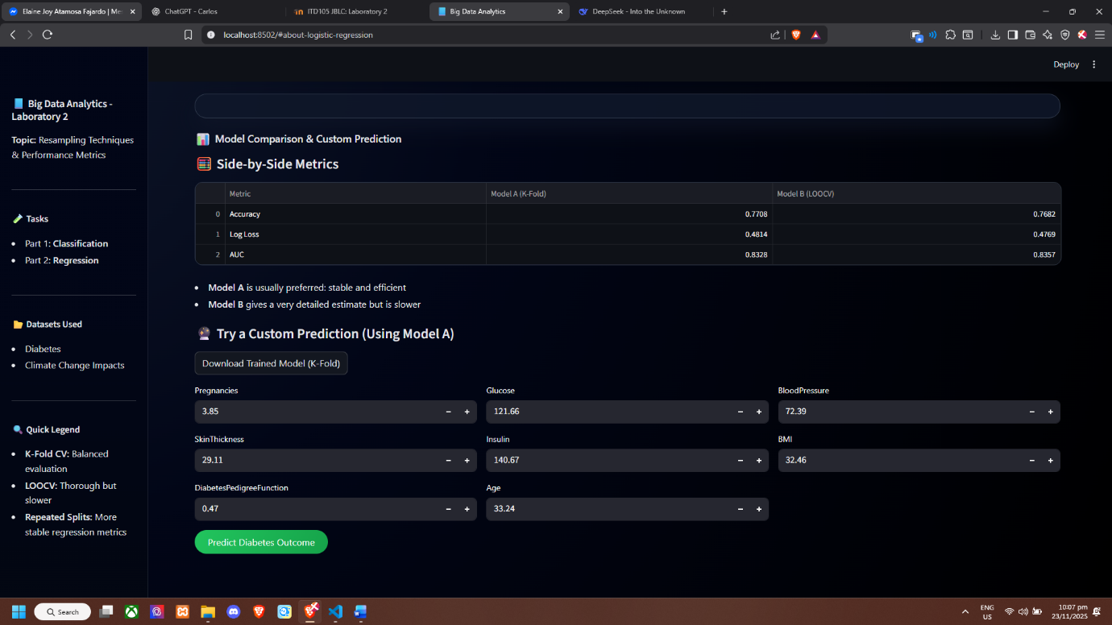

Part 2 Regression Task using Train-Test Split

Dataset: Look for an environment-related public dataset (regression type)

Instructions:
- Load the Dataset
- Build ML Model

ML Architecture | Model A | Model B
ML Algorithm | Linear Regression | Linear Regression
Resampling technique | Split into train and test sets | Repeated Random Train-Test splits
Performance Metrics | Mean Squared Error (MSE)  Mean Absolute Error (MAE)  R-squared (R²) | Mean Squared Error (MSE)  Mean Absolute Error (MAE)  R-squared (R²)

- What does each performance metric indicate? Interpret.
- MSE (Mean Squared Error):
  - What: Average of squared differences between predicted and actual values: (1/n) Σ (y_pred − y_true)².
  - Interpretation: Penalizes larger errors more heavily (sensitive to outliers). Lower is better. Use when you want to emphasize large deviations. Units are squared units of the target.

- RMSE (Root Mean Squared Error) (optional but useful):
  - What: Square root of MSE (√MSE).
  - Interpretation: Same meaning as MSE but on the original target scale — easier to interpret in real units. Lower is better.

- MAE (Mean Absolute Error):
  - What: Average absolute differences: (1/n) Σ |y_pred − y_true|.
  - Interpretation: Measures typical magnitude of error, less sensitive to outliers than MSE. Use when you want a robust, interpretable error metric in target units.

- R² (Coefficient of Determination):
  - What: Fraction of variance in the target explained by the model: 1 − (SS_res / SS_tot). Ranges ≤1.
  - Interpretation: Closer to 1 means the model explains more variance. R² = 0 means model is as good as predicting the mean; negative values mean worse than predicting the mean.

- Choose either Model A or Model B and explain your reasoning for selecting that model.
- Selected model: Model B — Repeated Random Train/Test Splits (averaged metrics)
  - Reasoning:
    - Repeated random splits reduce variance from a single arbitrary train/test partition by averaging performance across different random seeds. This typically yields more reliable estimates of expected performance on unseen data.
    - Model A (single split) is fast and simple but results can be strongly affected by one lucky/unlucky split, giving misleading metrics.
    - When the dataset is moderately sized (not tiny), repeated splits are affordable and recommended for assessing stability and robustness.
    - If you need a single final model for deployment, train on the full dataset after evaluating stability via repeated splits (or use cross-validation to tune hyperparameters then retrain on all data).

Summary recommendation: Use Model B for evaluation and stability; after selecting hyperparameters, retrain a final model on the full dataset for deployment.

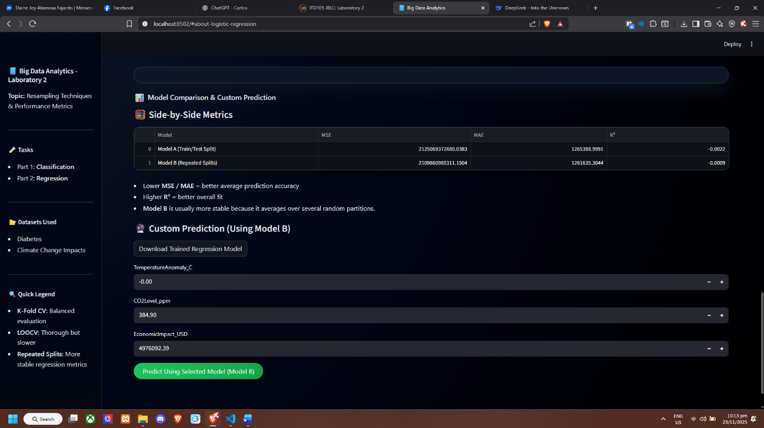
- Download the selected model and use it to make predictions. Integrate the model into a Streamlit application for interactive use.

Enhance the user-friendliness of your Streamlit app by organizing the layout with columns, tabs, and various interactive widgets for filtering and engaging with the data.

Submit the following:
- Source code (py. file)
- Datasets
- Video Screen record of your output (Max of 5mins only)
  - Explain the features and show sample predictions

